EX No. 3

Date: 25.7.22

AIM: To create a basic website with necessary attributes

Procedure:

1. Open notepad and type code
2. Save file as filename.html
3. Open file in any available browser

Code: MAIN SITE.

<style>

h1 {text-align : center;}

body {

}

.inform {

/\* margin-top: 6.5px;

margin-bottom: 6.5px; \*/

padding-top: 9px;

padding-bottom: 9px;

padding-left: 15%;

/\* border-radius: 10px; \*/

font-size: 24px;

}

form {

background-color:rgb(129, 240, 145);

}

.title {

background-color: rgb(232, 151, 3);

color:rgb(51, 33, 154)

}

input {

background-color: rgb(246, 246, 246);

}

</body>

</html>

</style>

</head>

<body style="background-color:rgb(49, 159, 215); opacity: 100px;">

<div style="padding-left: 40%; padding-right:25%; ">

<div class="title">

<form action="https://www.google.com" method="get">

<h1><u> ENTRANCE EXAM APPLICATION </u></h1>

<div class="inform">

<label for="fname">Fisrt Name</label>

<input type="text" id="fname" placeholder="Enter Name" name="name">

</div>

<div class="inform">

<label for="lname">Last Name</label>

<input type="text" id="lname" placeholder="Enter Last Name" name="lastname">

</div>

<div class="inform">

<label for="mob">Mobile Number</label>

<input type="number" id="mob" name="mbnr">

</div>

<div class="inform">

<label for="addr">Address</label><br>

<input type="text" id="addr" name="adnr" style="height: 200px;width:400px">

</div>

<div class="inform">

<label for="mob">Mobile Number</label>

<input type="number" id="mob" name="mbnr">

</div>

<div class="inform">

<label for="email">Email</label>

<input type="email" id="email" placeholder="Enter Email" name="mail">

</div>

<div class="inform">

<label for="dob">Date of Birth</label>

<input type="date" name="dobt" id="dob">

</div>

<div class="inform">

<label for="gender">Gender</label><br>

<label for="male">Male</label>

<input type="radio" name="gender" id="male">

<label for="female">Female</label>

<input type="radio" name="gender" id="female">

</div>

<div class="inform">

<label for="resume">Upload Passport sized photo</label>

<input type="file" id="photo" name="photo">

</div>

<div class="inform">

<label for="resume">Upload Signature photo</label>

<input type="file" id="signature" name="signature">

</div>

<button type="submit">Submit</button>

<style>

table {

font-family: arial, sans-serif;

border-collapse: collapse;

width: 100%;

}

td, th {

border: 1px solid #dddddd;

text-align: left;

padding: 8px;

}

tr:nth-child(even) {

background-color: #dddddd;

}

</style>

</head>

<body>

<h2>Venue and Time</h2>

<table>

<tr>

<th>Venue</th>

<th>Time</th>

</tr>

<tr>

<td>place1</td>

<td>time</td>

</tr>

<tr>

<td>place2</td>

<td>time</td>

</tr>

<tr>

<td>place3</td>

<td>time</td>

</tr>

</table>

<p>click the link to read rules and regulations</p>

<a href="file:///C:/Users/dell/Downloads/lab3link.html">Rules and regulations</a>

</body>

</html>

Code: LINKED SITE

<html>

<head>

<title> Rules and Regulations</title>

<style>

h1 {text-align : center;}

</style>

</head>

<body>

<h1 style="color:rgb(255, 4, 21)"> Rules and Regulations</h1>

<ol>

<li>Slots will be allotted to the candidates to arrive at the exam centres. Candidates must follow the allotted slots and arrive at the centre only at their designated time for to make the entry process smoother and follow the social distancing norms.</li>

<li>The seating area, monitor, keyboard, mouse, webcam, desk, and chair will be thoroughly sanitised before and after each exam shift. All door handles, staircase railing, lift buttons, etc., will also be carefully disinfected.</li>

<li>The security personnel at the exam centre shall check the body temperature of each candidate using thermal guns at the entry point.</li>

<li>Hand sanitisers will be kept at the entrance of the exam venue. Every candidate must sanitise their hands before entering the examination hall.</li>

<li>Candidates will be required to wear the fresh masks provided at the exam centre and remove their worn masks.</li>

<li>Candidates are allowed to carry a personal hand sanitiser and transparent water bottle.</li>

<li>A gap between the two seats inside the examination hall will be maintained per the GOI guidelines.</li>

<li>Admit card will be checked through a bar code reader, and frisking will be through metal detectors to avoid touch. No contact norms are to be followed.</li>

<li>Parents are advised not to stay at the exam centres during exam time.</li>

<li>Candidates must keep a minimum distance of at least 6 feet at the premises.</li>

<li>shoes/ footwear with thick soles and garments with large buttons are not permitted.</li>

</ol>

<h2 style="color:rgb(0, 0, 0)">Here are the important instructions related to the ID card, admit card, and other documents required at the exam centre:</h2>

<ol>

<li>Candidates must carry the Admit Card and a valid photo ID proof to the exam hall. Failing to do this, you will not be allowed to give the test.</li>

<li>Visit the exam centre one day before the exam and report to the exam hall 60 minutes before the commencement of the exam. This will help you avoid last-minute problems.</li>

<li>A seat indicating Roll Number will be allocated to each candidate. You should find yours and occupy the allocated seat only. If you are found to have changed your seat, your candidature will be cancelled.</li>

<li>Students need to carry their geometry boxes and stationeries.</li>

<li>Carry a copy of the documents required at the exam centre and submit the same to the invigilator at the examination centre.</li>

<li>Write your Roll No. on the copy of the documents required at the exam centre that you will submit.</li>

<li>Carry an original copy of a valid photo identity proof issued by the government (PAN Card, Driving Licence, Voter ID, Passport, Aadhaar Card with Photograph, E-Aadhar, Ration Card, Aadhaar Enrollment Number with Photo) to the examination hall.</li>

<li>Carry PwD Certificate issued by a competent authority</li>

</ol>

<p> Click to go back to Application page</p>

<a href="C:\Users\dell\Downloads\lab3.html">Application</a>

</body>

</html>

OUTPUT:

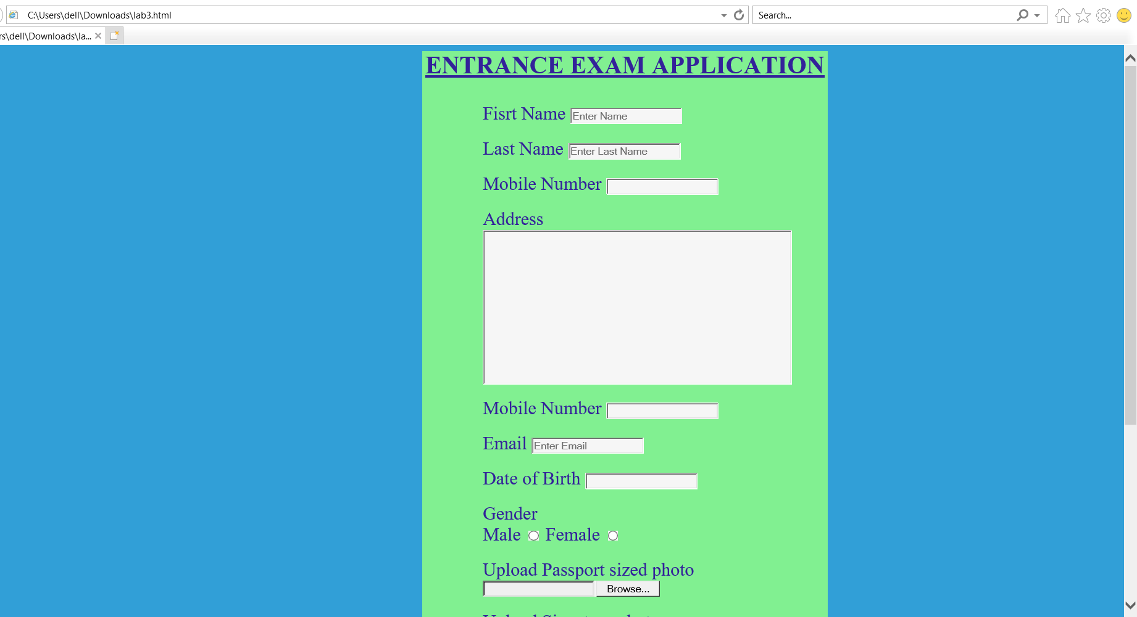

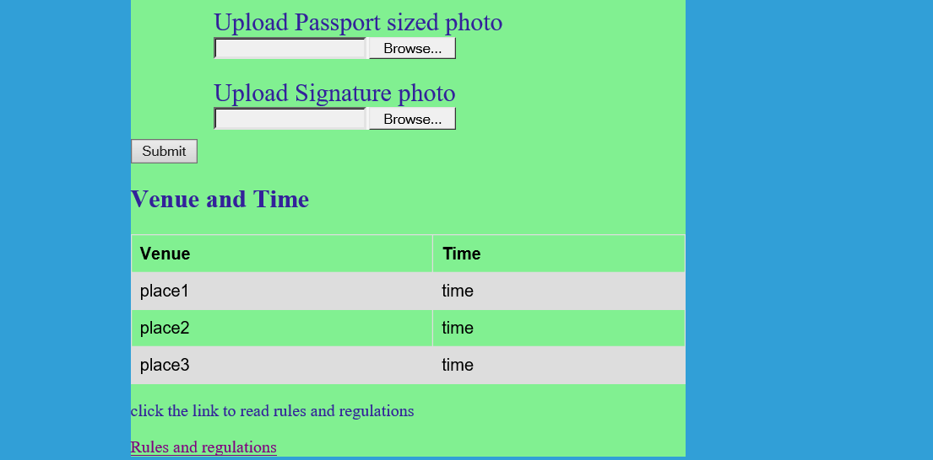

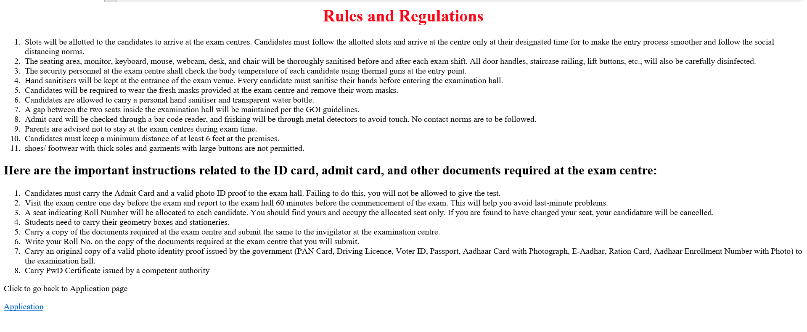

LINK:

C:\Users\dell\Downloads\lab3.html

RESULT: The site was created successfully.